


Vehicle Exhaust
Removal Systems
Installation Project
Corvallis Fire Department
Corvallis, OR
August 7, 2026

Table of Contents

- About Salty Peaks
- From the Project Team
- Tiered Proposal Outlines
- Systems Components
- Tiered Proposal Outlines
- Chart: Cost Comparison By Station
- Price Tier Parts Breakouts
- Selections And Signatures
- Customer Information
- Preventative Maintenance
- System Warranty

About Us


Diesel Exhaust Ventilation Systems Parts, Install, and Service Specialists
As your local MagneGrip Systems Distributor, Salty Peaks Solutions is committed to providing excellence across all aspects of diesel exhaust ventilation and air filtration systems. It is our pleasure to guide you through each step of the product life cycle including tailored estimates, custom installation applications, preventative maintenance service, and parts supply. With a combined 25 years of expertise, our team of specialists guarantees an industry leading experience to ensure your systems are functioning flawlessly for years to come, providing vital exposure mitigation to the men and women of fire departments across the Western region.
Corvallis Project Team

Curtis Drage
Project Director

Parker Mildenhall
Sales & Service Account Manager

Mike Thomas
Installation Contractor

From the Project Team
Dear Tony,

We appreciate the opportunity to outline the best solutions for each of your Corvallis Fire Department Stations. We are committed to providing industry-leading technology as part of your exposure and cancer mitigation protocols to protect the men and women working in proximity to the dangers of diesel exhaust. This is just one step in building a years-long relationship where our teams work hand-in-hand to provide your departments with excellent sales, service, and maintenance for the lifetime of your MagneGrip systems.

The following proposal outlines custom solutions for each of the stations we visited, with specifications to address the unique architecture, layouts, vehicles, and needs of the wide variety of Corvallis Fire Department locations. Each solution was designed with your primary goals of providing efficient, robust, and aesthetically uncompromised rail or flex hose systems for each application. Our goal with each solution is to mitigate future problems for each of the unique scenarios and use our 25 years combined knowledge and experience to ensure that these options will provide best outcomes for years to come. We look forward to continuing a long-term partnership for you and your department and can’t wait to get started!
Sincerely,
Mike Thomas
Installations Contractor
mike@saltypeakssolutions.com
(385) 229 9464

Curtis Drage
Project Director
curtis@saltypeakssolutions.com
(801) 792 6505

Parker Mildenhall
Sales & Service Account Manager
parker@saltypeakssolutions.com
(801) 699 5307

MAGNEGRIP SYSTEM COMPONENTS:
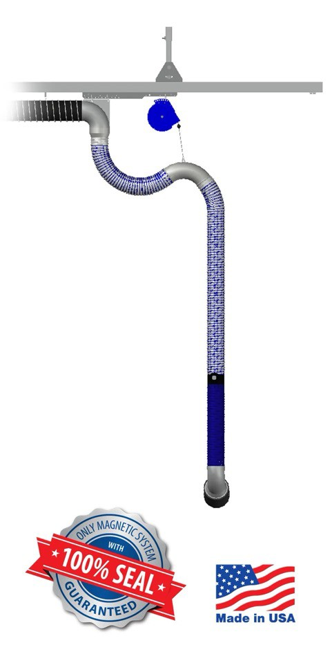
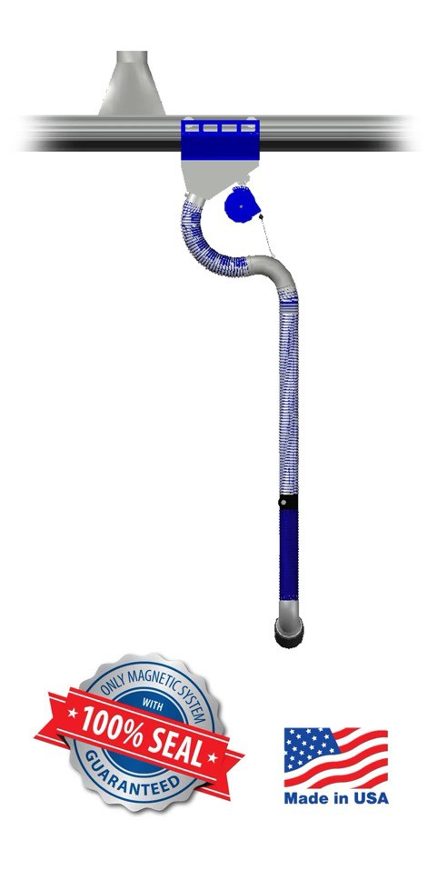
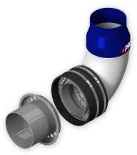
PRO NOZZLE:

- High Temp Hose Lower

- Horizontally aligned magnets for improved seal and release compared to the OG design
STRAIGHT SUCTION RAIL (SSRM):

- Works for back-in or drive-through bays
- Supports tandem parking (up to four vehicles)
- Auto-start sensor + automatic disconnect

SLIDING FLEXHOSE TRACK (SFT):

- Compact for low ceilings / narrow aisles (19–24 in.)
- Fully automatic; fan can auto-start
- Budget Friendly Sealed “no-loop” design

TIERED PROPOSAL OUTLINES:
Tier 1 Summary: Replaces only worn, damaged, or missing parts, lowers, adapters, transmitters and receivers.
- All PRO Hose lowers and PRO tailpipe adapters
  - Addresses the need for high temp hose lowers, handles, functional receivers and transmitters
  - Install missing tailpipe adapters and reducers
- Replace worn Nederman hoses with MagnaGrip Hoses
  - Addresses mixed manufacturing and adapter incompatibility across stations and apparatus.
- Install missing hose drops
- Replace unused Vertical Stack Rail with a Flex Hose System
- Training Facility system at full price of parts and install
COST: $122,154.24
Tier 2 Summary: Replaces priority station systems with PRO Flex Hose Tracks, which also allows for a heavily discounted Training Facility System. Replaces worn, damaged, or missing parts, lowers, adapters, transmitters and receivers in the non-priority stations.
- Install PRO Flex Hose Tracks and Straight Suction Rail at Stations 1, 2, 3
- Reuse Sliding Balancer Track at Training Facility – labor, fan, and control panel cost only.
- Non-Priority Stations 4, 5, 6 with PRO Hose lowers and PRO tailpipe adapters
  - Addresses the need for high temp hose lowers, handles, functional receivers and transmitters
  - Install missing tailpipe adapters and reducers
- Replace worn Nederman hoses with MagnaGrip Hoses
  - Addresses mixed manufacturing and adapter incompatibility across stations and apparatus.
- Install missing hose drops
- Replace Vertical Stack Rail with a Flex Hose System
- Suction rail on double stack vehicles

COST: $276,966.97

Tier 3 Summary: All Stations in new PRO Flex Hose Systems and Straight Suction Rail where applicable.

COST: $325,548.97

Tiered Proposal Cost Comparison by Station:

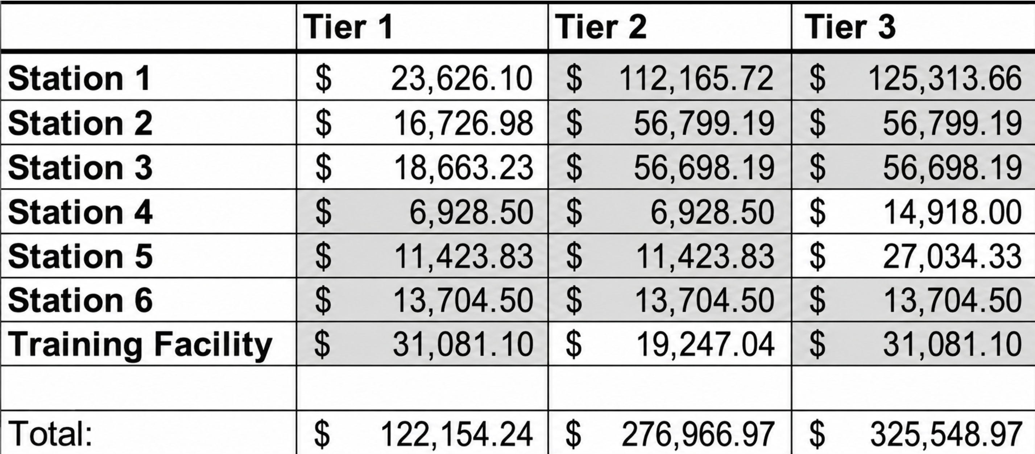
PRICE TIER PARTS BREAKOUTS
Tier 1 Proposal Breakout:

Station 1: 400 NW Harrison Blvd

(7) MAG 550010-04 Magnegrip Pro Upgrade Kit 4"
(7) MAG 530621-02 Handle Knob 4" assy W/O Hose
(1) MAG SHDMPRO-413 Simple hose drop with Magnegrip PRO
(1) MAG 550010-05 MAG PRO Upgrade kit
(1) MAG 500095-11 5" x 11' Hose
(1) MAG 500071-05 Pressure sensor with wire connections
(1) MAG 540557-08 Transmitter Acutek 2022 SC w/ Capacitor for pressure sensor
(1) MAG 540020-01 TP Elbow 4" ID OD 45 degree
(1) MAG 540050-35 Tailpipe kit 3.5"
(1) MAG 500214-01 Extension 4" x 24"
(1) MAG 540555-01 Receiver Acutek
(1) MagneGrip Installation includes equipment installation, travel, equipment rental, spiral duct & fittings, hardware, start up, and training

PRICE $23,626.10

Station 2: 500 SW 35th Street

(1) MAG SHDMPRO-413 Simple hose drop with Magnegrip PRO (Medic Bay Nederman Conversion)
(1) MAG 540557-08 Transmitter Acutek 2022 SC w/ Capacitor for pressure sensor (Medic Bay Nederman Conversion)
(1) MAG 500071-05 Pressure sensor with wire connections (Medic Bay Nederman Conversion)
(2) MAG 540555-01 Receiver Acutek (Medic Bay Nederman Conversion) + (Main App Bay)
(2) MAG 540050-35 Tailpipe kit 3.5"
(4) MAG 530621-02 Handle Knob 4" assy W/O Hose (Main App Bay)
(4) MAG 550010-04 Magnegrip Pro Upgrade Kit 4" (Main App Bay)
(1) MAG 540556-01 Acutek push button transmitter
(1) MagneGrip Installation includes equipment installation, travel, equipment rental, spiral duct & fittings, hardware, start up, and training

PRICE $16,726.98

Station 3: 1310 NW Circle Blvd

(1) MAG SHDMPRO-413 Simple hose drop with Magnegrip PRO (Medic Bay Nederman Conversion)
(1) MAG 500084-04 Blue balancer assembly complete (Medic Bay)
(1) MAG 540557-08 Transmitter Acutek 2022 SC w/ Capacitor for pressure sensor (Medic Bay Nederman Conversion)
(1) MAG 500071-05 Pressure sensor with wire connections (Medic Bay Nederman Conversion)
(2) MAG 540555-01 Receiver Acutek (Medic Bay Nederman Conversion) + (Main App Bay)
(2) MAG 540050-35 Tailpipe kit 3.5"
(2) MAG 500006-06 Track Alum Accu Track 6' (Main App Bay)
(4) MAG 530621-02 Handle Knob 4" assy W/O Hose (Main App Bay)
(4) MAG 550010-04 Magnegrip Pro Upgrade Kit 4" (Main App Bay)
(1) MAG 500094-21 4" 21' Hose (Main App Bay)
(1) MAG 530306-2 5" Riser and 6' Leg Assembly (Main App Bay)
(1) MAG 540556-01 Acutek push button transmitter
(1) MagneGrip Installation includes equipment installation, travel, equipment rental, spiral duct & fittings, hardware, start up, and training

PRICE $18,663.23

Station 4: 365 SW Tunison

(2) MAG 530621-02 Handle Knob 4" assy W/O Hose
(2) MAG 550010-04 Magnegrip Pro Upgrade Kit 4"
(1) MAG 540555-01 Receiver Acutek
(1) MagneGrip Installation includes equipment installation, travel, equipment rental, spiral duct & fittings, hardware, start up, and training
PRICE………………………………………………………………………………………………………………..$6,928.50

Station 5: 4950 NW Fair Oaks Dr

(2) MAG 550010-04 Magnegrip Pro Upgrade Kit 4"
(2) MAG 530621-02 Handle Knob 4" assy W/O Hose
(1) MAG SHDMPRO-413 Simple hose drop with Magnegrip PRO
(1) MAG 540555-01 Receiver Acutek
(1) MAG 540556-01 Acutek push button transmitter
(1) MagneGrip Installation includes equipment installation, travel, equipment rental, spiral duct & fittings, hardware, start up, and training

PRICE $11,423.83

Station 6: 544 NW Lewisburg Ave

(1) MAG SFTMPRO-361 36ft Flex hose system
(1) MAG 540050-35 Tailpipe kit 3.5"
(1) MAG 540022-01 TP Elbow 4" ID OD 30 degree
(3) MAG 400073-02 MAGPRO TPA with 5" clamp
(3) MAG 550010-05 MAG PRO Upgrade kit
(1) MAG 500071-05 Pressure sensor with wire connections
(1) MagneGrip Installation includes equipment installation, travel, equipment rental, spiral duct & fittings, hardware, start up, and training

PRICE $13,704.50

Training Station: 1275 NE 3rd St.

(1) MAG 500174-08 2hp 1ph Control Panel
(1) MAG CF363-2 2hp 3ph Cincinnati Fan
(1) MAG 540020-01 TP Elbow 4" ID OD 45 degree
(2) MAG SFTMPRO-301 30ft Flex hose system
(1) MagneGrip Installation includes equipment installation, travel, equipment rental, spiral duct & fittings, hardware, start up, and training

PRICE $31,081.10

TIER 1 TOTAL COST: $122,154.24

Tier 2 Proposal breakout:

Station 1: 400 NW Harrison Blvd

(8) MAG SFTMPRO-301 30ft Flex hose system
(1) MAG SSRMPRO-481 48ft Straight suction rail with 1 hose drop
(1) MAG SFTMPRO-481 Sliding Flex Track MAG PRO
(1) Mag 50042-05 Magnegrip pro crab assembly
(1) MAG 500214-01 Extension 4" x 24"
(1) MAG 540020-01 TP Elbow 4" ID OD 45 degree
(1) MagneGrip Installation includes equipment installation, travel, equipment rental, spiral duct & fittings, hardware, start up, and training

PRICE $112,165.27

Station 2: 500 SW 35th Street

(1) MAG SFTMPRO-301 30ft Flex hose system (Medic Bay)
(2) MAG 540555-01 Receiver Acutek (Medic Bay Nederman Conversion) + (Main App Bay)
(2) MAG 540050-35 Tailpipe kit 3.5"
(1) MAG 540556-01 Acutek push button transmitter
(2) MAG SSRMPRO-601 60ft Straight suction rail with 1 hose drop (Main App Bay)
(2) MAG 520042-05 MagneGrip Pro crab assembly complete (Main App Bay)
(1) MagneGrip Installation includes equipment installation, travel, equipment rental, spiral duct & fittings, hardware, start up, and training

PRICE $56,799.19

Station 3: 1310 NW Circle Blvd

(1) MAG SFTMPRO-301 30ft Flex hose system (Medic Bay)
(2) MAG 540555-01 Receiver Acutek (Medic Bay) + (Main App Bay)
(1) MAG 540556-01 Acutek push button transmitter
(2) MAG SSRMPRO-601 60ft Straight suction rail with 1 hose drop (Main App Bay)
(2) MAG 520042-05 MagneGrip Pro crab assembly complete (Main App Bay)
(1) MAG 540050-35 Tailpipe kit 3.5"
(2) MAG 540020-01 TP Elbow 4" ID OD 45 degree
(1) MagneGrip Installation includes equipment installation, travel, equipment rental, spiral duct & fittings, hardware, start up, and training
PRICE $56,698.19

Station 4: 365 SW Tunison

(2) MAG 530621-02 Handle Knob 4" assy W/O Hose
(2) MAG 550010-04 Magnegrip Pro Upgrade Kit 4"
(1) MAG 540555-01 Receiver Acutek
(1) MagneGrip Installation includes equipment installation, travel, equipment rental, spiral duct & fittings, hardware, start up, and training
PRICE $6,928.50

Station 5: 4950 NW Fair Oaks Dr

(2) MAG 550010-04 Magnegrip Pro Upgrade Kit 4"
(2) MAG 530621-02 Handle Knob 4" assy W/O Hose
(1) MAG SHDMPRO-413 Simple hose drop with Magnegrip PRO
(1) MAG 540555-01 Receiver Acutek
(1) MAG 540556-01 Acutek push button transmitter
(1) MagneGrip Installation includes equipment installation, travel, equipment rental, spiral duct & fittings, hardware, start up, and training

PRICE $11,423.83

Station 6: 544 NW Lewisburg Ave

(1) MAG SFTMPRO-361 36ft Flex hose system
(1) MAG 540050-35 Tailpipe kit 3.5"
(1) MAG 540022-01 TP Elbow 4" ID OD 30 degree
(3) MAG 400073-02 MAGPRO TPA with 5" clamp
(3) MAG 550010-05 MAG PRO Upgrade kit
(1) MAG 500071-05 Pressure sensor with wire connections
(1) MagneGrip Installation includes equipment installation, travel, equipment rental, spiral duct & fittings, hardware, start up, and training

PRICE $13,704.50

*Discounted* Training Station: 1275 NE 3rd St.

(1) MAG CF363-2 2hp 3ph Cincinnati Fan
(1) MAG 500175-08 2hp 3ph Control Panel
(2) MAG 530621-02 Handle Knob 4" assy W/O Hose
(2) MAG 550010-04 Magnegrip Pro Upgrade Kit 4"
(1) MAG 540020-01 TP Elbow 4" ID OD 45 degree
(1) MagneGrip Installation includes equipment installation, travel, equipment rental, spiral duct & fittings, hardware, start up, and training
PRICE $19,247.04

TIER 2 TOTAL COST: $276,966.97

Tier 3 Proposal breakout:

Station 1: 400 NW Harrison Blvd

(7) MAG SFTMPRO-301 30ft Flex hose system
(1) MAG SSRMPRO-481 48ft Straight suction rail with 1 hose drop
(1) MAG SFTMPRO-481 Sliding Flex Track MAG PRO
(1) (1) Mag 50042-05 Magnegrip pro crab assembly
(1) MAG CF363-10 10hp 3ph Cincinnati Fan
(1) MAG 500183-08 10hp 3ph Control Panel
(1) MAG 500157-16 16" Upblast, backdraft rain cap
(1) MAG 500151-16 16" Silencer
(1) MAG 500214-01 Extension 4" x 24"
(1) MAG 540020-01 TP Elbow 4" ID OD 45 degree
(1) MagneGrip Installation includes equipment installation, travel, equipment rental, spiral duct & fittings, hardware, start up, and training

PRICE $125,313.66

Station 2: 500 SW 35th Street

(1) MAG SFTMPRO-301 30ft Flex hose system (Medic Bay)
(2) MAG 540555-01 Receiver Acutek (Medic Bay Nederman Conversion) + (Main App Bay)
(2) MAG 540050-35 Tailpipe kit 3.5"
(1) MAG 540556-01 Acutek push button transmitter
(2) MAG SSRMPRO-601 60ft Straight suction rail with 1 hose drop (Main App Bay)
(2) MAG 520042-05 MagneGrip Pro crab assembly complete (Main App Bay)
(1) MagneGrip Installation includes equipment installation, travel, equipment rental, spiral duct & fittings, hardware, start up, and training

PRICE $56,799.19

Station 3: 1310 NW Circle Blvd

(1) MAG SFTMPRO-301 30ft Flex hose system (Medic Bay) 1
(2) MAG 540555-01 Receiver Acutek (Medic Bay) + (Main App Bay)
(1) MAG 540556-01 Acutek push button transmitter
(2) MAG SSRMPRO-601 60ft Straight suction rail with 1 hose drop (Main App Bay)
(2) MAG 520042-05 MagneGrip Pro crab assembly complete (Main App Bay)
(1) MAG 540050-35 Tailpipe kit 3.5" 1
(2) MAG 540020-01 TP Elbow 4" ID OD 45 degree
(1) MagneGrip Installation includes equipment installation, travel, equipment rental, spiral duct & fittings, hardware, start up, and training
PRICE $56,698.19

Station 4: 365 SW Tunison

(2) MAG SFTMPRO-301 30ft Flex hose system SBT conversion
(1) MAG 540555-01 Receiver Acutek
(1) MagneGrip Installation includes equipment installation, travel, equipment rental, spiral duct & fittings, hardware, start up, and training
PRICE $14,918.00

Station 5: 4950 NW Fair Oaks Dr

(3) MAG SFTMPRO-361 36ft Flex hose system
(1) MAG 540555-01 Receiver Acutek
(1) MAG 540556-01 Acutek push button transmitter
(1) MagneGrip Installation includes equipment installation, travel, equipment rental, spiral duct & fittings, hardware, start up, and training

PRICE $27,034.33

Station 6: 544 NW Lewisburg Ave

(1) MAG SFTMPRO-361 36ft Flex hose system
(1) MAG 540050-35 Tailpipe kit 3.5"
(1) MAG 540022-01 TP Elbow 4" ID OD 30 degree
(3) MAG 400073-02 MAGPRO TPA with 5" clamp
(3) MAG 550010-05 MAG PRO Upgrade kit
(1) MAG 500071-05 Pressure sensor with wire connections
(1) MagneGrip Installation includes equipment installation, travel, equipment rental, spiral duct & fittings, hardware, start up, and training

PRICE $13,704.50

Training Station: 1275 NE 3rd St.

(1) MAG 500174-08 2hp 1ph Control Panel 1
(1) MAG CF363-2 2hp 3ph Cincinnati Fan 1
(1) MAG 540020-01 TP Elbow 4" ID OD 45 degree 1
(2) MAG SFTMPRO-301 30ft Flex hose system 2
(1) MagneGrip Installation includes equipment installation, travel, equipment rental, spiral duct & fittings, hardware, start up, and training
PRICE $31,081.10

TIER 3 TOTAL COST: $325,548.97

FINAL SELECTIONS:
Station 1:
Station 2:
Station 3:
Station 4:
Station 5:
Station 6:
Training Station:
ACCEPTED BY:
Company:_________________________
Print: _____________________________
Sign: _____________________________
Title: _____________________________
Date: _____________________________
PO #, If Required: __________________

SUBMITTED BY:
Salty Peaks Solutions
_________________________________
Curtis Drage, Outside Sales & Service
_________________________________
Date

Responsive Support

We offer 24/7 Call and Text Customer Support at (801)7926505. We also provide service requests and bids through our online portal. Additionally, your local rep can be reached during normal business hours via call, text, or email. Shipping on parts takes 2-3 days. Full system installations are coordinated promptly and can be completed 4-6 weeks after an order is placed. Our sales, service, and install team is available for any other questions throughout the process of installation or maintenance and are happy to assist with any level of inquiry.

Low-Cost Maintenance

MagneGrip’s industry leading 100% sealed, magnetic system has been proven to reduce maintenance by 70% compared to other systems on the market. The high-quality and simplicity of the MagneGrip system ensures less maintenance and repairs, resulting in fewer issues and far fewer dollars spent on parts. Much like an oil change on a vehicle, regular quarterly maintenance will greatly increase the longevity and efficacy of your system, and we offer both training and preventative maintenance plans to assist with this.

Preventative Maintenance Plans

As part of our regular service commitment, your local service technician will connect quarterly to assist with system checks to ensure correct functionality of all aspects of your install such as sensor function, rail lubrication, nozzle fitment, and hose integrity. Annual service contracts are also available at $649 per station for a yearly visit to perform the recommended annual maintenance, cleaning, and any parts installations.

USA Certified
Along with our extensive nation-wide, local service and maintenance providers, MagneGrip is the only exhaust removal system that is accredited by the Buy American Law – certifying that all MagneGrip® parts and components are proudly manufactured and assembled in the USA.

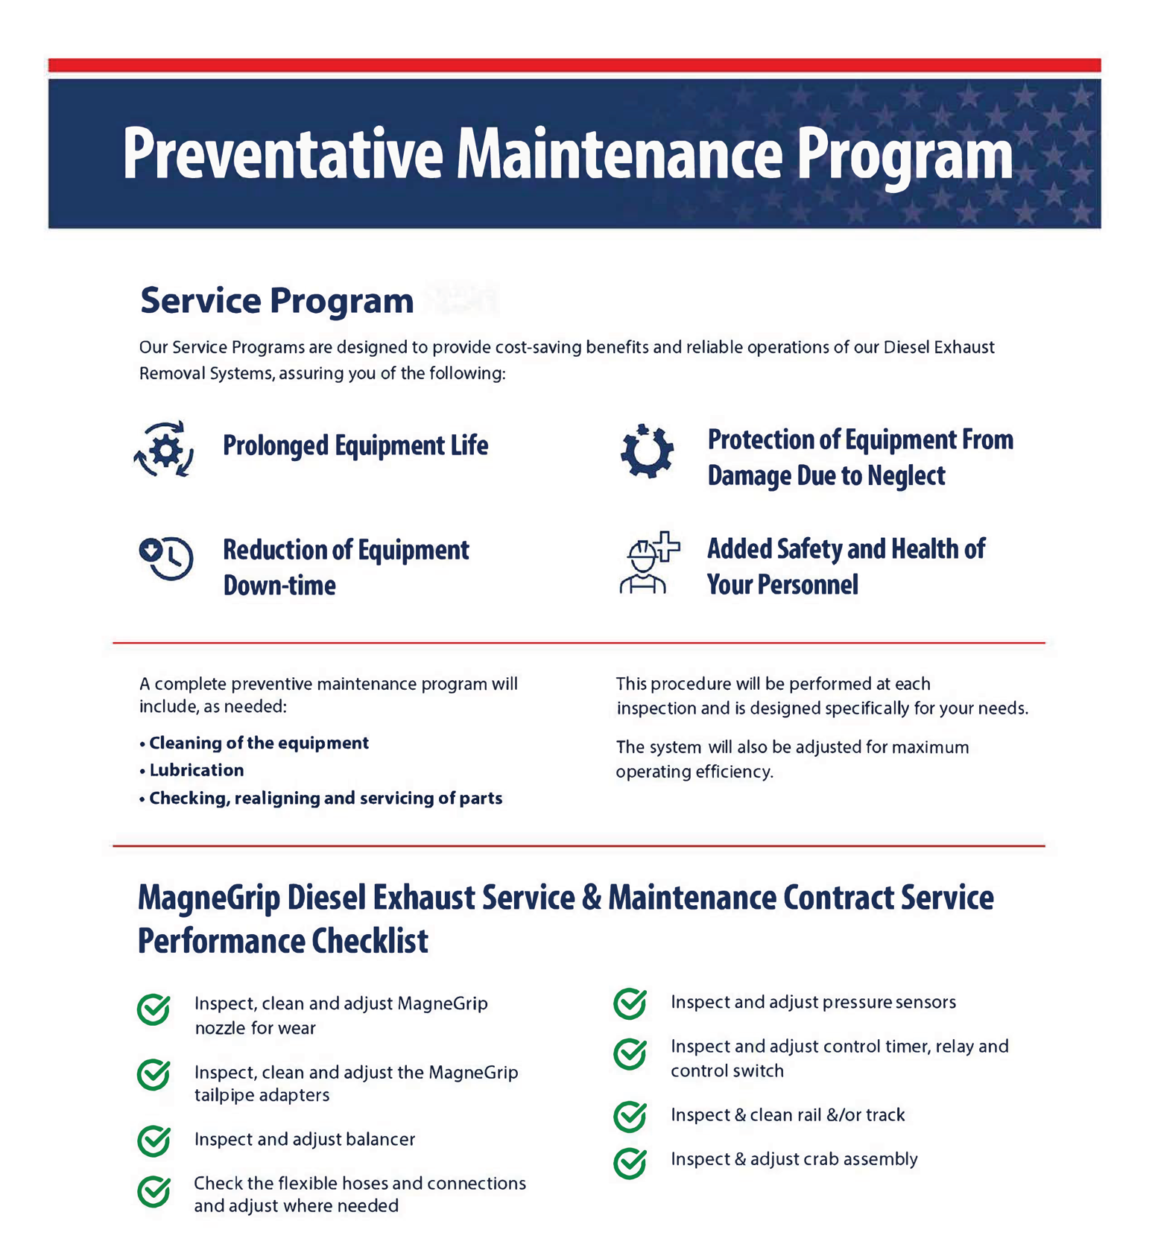
Warranty

Write copy about the type of warranty you offer. WAITING ON ALLISON.

Lifetime Structural Warranty

MagneGrip offers a Lifetime Structural Warranty on All Duct Material, Track and Rail, and Telescoping Support Legs.

VERBIAGE FROM MAGNEGRIP

