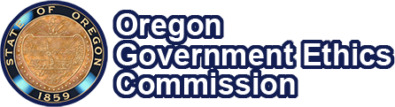

November 20, 2025

New Year, New Changes to Ethics Law


Image - Golden Man statue looks to the right across the Salem skyline

Changes to Government Ethics Law!
During the 2025 legislative session, House Bill 2930 passed. This bill changes the definition of the Conflict of Interest provisions in Oregon Government Ethics Law to add public officials' household members.

Change becomes law on January 1, 2026. Here’s what to know:
Starting on January 1st, the Conflict of Interest provisions will apply to public officials, their relatives, and members of their household, and any business that a public official, or their relative, or a member of their household is associated with.
In Oregon Government Ethics Law, a member of the household is anyone who lives in a public official’s home. Members of the household share an address with the public official.

How does this affect you as a public official?
Public officials are required to make proper disclosures of their conflicts of interest.
HB 2930 means that next year, a public official will be met with a conflict of interest when that public official is taking an official action (a vote, decision, or recommendation)
And
- The action would or could have a private financial impact
- The financial impact can be a benefit (gain) or a detriment (loss)
- The impact is on the public official, or their relative, or a member of their household, or any businesses that any of them are associated with.
The requirements for declaring conflicts of interest have not changed. They are different for employees than for elected public officials, members of boards, councils, and commissions. See OGEC's Reference Guide on Conflicts of Interest for more details about requirements.

Sign Up For Updates

View Enrolled Bill

Oregon Government Ethics Commission
3218 Pringle Road SE, Suite 220
Salem, OR 97302
(503) 378-5105 | mail@ogec.oregon.gov | www.oregon.gov/OGEC


